**Harshil Bhardwaj**

**Topic:- code file of web**

* **Name :-Harshil Bhardwaj.**
* **To:- My cyber team .**
* **Class:- Zone 18 & 19 .**

**Welcome to the web report**

**Note:- please open this website in laptop only.**

**Web: file:///C:/Users/DELL/Desktop/website(3)/index.html#bannre.**

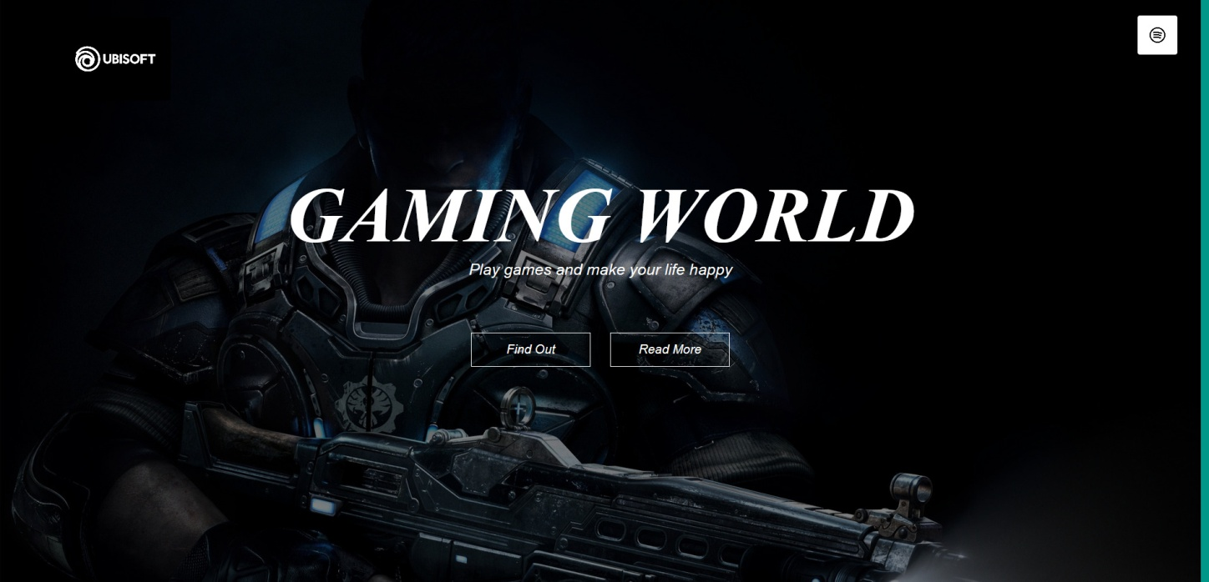

**Html codes for out look:-**

<html>

<head>

<title>$-Harshil Bhardwaj-$</title>

<link rel="stylesheet" type="text/css" href="style.css">

<meta name="viewport" content="width=device-width, initial-scale=1">

<link rel="stylesheet" type="text/css" href="https://stackpath.bootstrapcdn.com/font-awesome/4.7.0/css/font-awesome.min.css">

<script src="https://cdn.jsdelivr.net/gh/cferdinandi/smooth-scroll/dist/smooth-scroll.polyfills.min.js"></script>

</head>

<body>

<section id="banner">

<img src="images/B612_20210111_122320_160.jpg" class="logo">

<div class="banner-text">

<h1>GAMING WORLD</h1>

<p>Play games and make your life happy</p>

<div class="banner-btn">

<a href="#"><span></span>Find Out</a>

<a href="#"><span></span>Read More</a>

</div>

</div>

</section>

<div id="sideNav">

<nav>

<ul>

<li><a href="#banner">Home</a></li>

<li><a href="#Features">Features</a></li>

<li><a href="#Services">services</a></li>

<li><a href="#Testimonial">Testimonials</a></li>

<li><a href="#Download">Download</a></li>

</ul>

</nav>

</div>

<div id="menuBtn">

<img src="images/87409.png" id="menu">

</div>

**Style codes of out look:-**

*{

margin: 0;

padding: 0;

font-family: 'Poppins' , sans-serif;

}

#banner{

background-image:linear-gradient(rgba(0,0,0,0.5),rgba(0,0,0,0.5))

, url(images/263591.jpg);

background-size: cover;

background-position: center;

height: 100vh;

}

.logo{

width: 140px;

position: absolute;

top: 3%;

left: 5%;

}

.banner-text{

text-align: center;

color: #fff;

padding-top: 220px;

font-style: italic;

top: 50%;

}

.banner-text h1{

font-size: 100px;

font-family: 'kaushan script', curive;

}

.banner-text p{

font-size: 20px;

font-style: italic;

}

.banner-btn{

margin: 70px auto 0;

}

.banner-btn a{

width: 150px;

text-decoration: none;

display: inline-block;

margin: 0 10px;

padding: 12px 0;

color: #fff;

border: .5px solid #fff;

position: relative;

z-index: 1;

transition: color 0.5s;

}

.banner-btn a span{

width: 0;

height: 100%;

position: absolute;

top: 0;

left: 0;

background: #fff;

z-index: -1;

transition: 0.5s;

}

.banner-btn a:hover span{

width: 100%;

}

.banner-btn a:hover {

color: #000;

}

#sideNav{

width: 250px;

height: 100vh;

position:fixed;

right: -250px;

top: 0;

background: #efefef;

z-index: 2;

transition: 0.5s;

}

nav ul li{

list-style: none;

margin: 50px 20px

}

nav ul li a{

text-decoration: none;

color: #000;

}

#menuBtn{

width: 50px;

height: 50px;

background: #fff;

text-align: center;

position: fixed;

right: 30px;

top: 20px;

border-radius: 3px;

z-index: 3;

cursor: pointer;

}

#menuBtn img{

width: 20px;

margin-top: 15px;

}

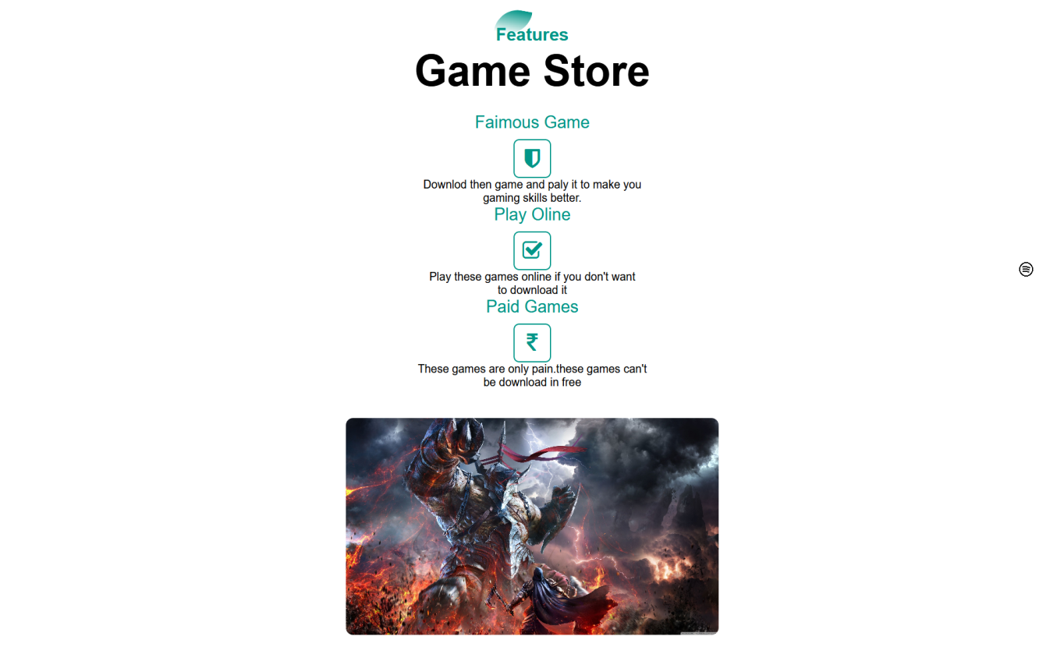

**Html codes for out of 2 page:-**

<!--Features-->

<section id="Features">

<div class="title-text">

<p>Features</p>

<h1> Game Store</h1>

</div>

<div class="Features-box">

<div class="Features">

<h1>Faimous Game</h1>

<div class="Features-desc">

<div class="Features-icon">

<i class="fa fa-shield"></i>

</div>

<div class="Features-text">

<p>Downlod then game and paly it to make you<br>

gaming skills better. </p>

</div>

<h1>Play Oline</h1>

<div class="Features-desc">

<div class="Features-icon">

<i class="fa fa-check-square-o"></i>

</div>

<div class="Features-text">

<p>Play these games online if you don't want<br> to download it </p>

</div>

<h1>Paid Games</h1>

<div class="Features-desc">

<div class="Features-icon">

<i class="fa fa-inr"></i>

</div>

<div class="Features-text">

<p>These games are only pain.these games can't<br> be download in free</p>

</div>

</div>

<div class="Features-img">

<img src="images/168336.jpg">

</div>

</div>

</section>

**Style codes for 2 page:-**

/*--Features--*/

#Features{

width: 100%;

padding: 70px 0;

}

.title-text{

text-align: center;

'padding-bottom: 70px;

}

.title-text p{

margin: auto;

font-size: 25px;

color: #009688;

font-weight: bold;

position: relative;

z-index: 1;

display: inline-block;

}

.title-text p::after{

content: '';

width: 50px;

height: 35px;

background: linear-gradient(#019587,#fff);

position: absolute;

top: -20px;

left: 0;

z-index: -1;

transform: rotate(10deg);

border-top-left-radius: 35px;

border-bottom-right-radius: 35px;

}

.title-text h1{

font-size: 60px;

}

.Features-box{

width: 50%;

margin: auto;

display: flex;

flex-wrap: wrap;

align-items: center;

text-align: center;

}

.Features{

padding-top: 3%;

flex-basis: 120%;

}

.Features-img img{

width: 70%;

border-radius: 10px;

}

.Features h1{

text-align: center;

margin-bottom: 10px;

font-weight: 100;

color: #009688;

}

.Features-desc{

align-items: center;

margin-bottom: 40px;

}

.Features-icon .fa{

width: 50px;

height: 50px;

font-size: 30px;

line-height: 50px;

border-radius: 8px;

color: #009688;

border: 2px solid #009688;

}

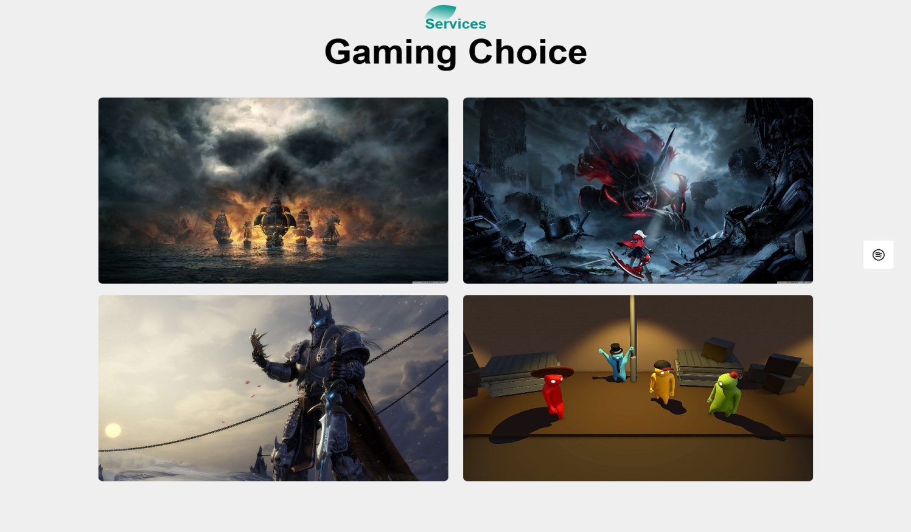

**Html codes for 3 page:-**

<!--Services -->

<section id="Services">

<div class="title-text">

<p>Services</p>

<h1> Gaming Choice</h1>

</div>

<div class="Services-box">

<div class="single-Services">

<img src="images/17611.jpg">

<div class="overlay"></div>

<div class=" services-desc">

<h3><i class="fa fa-shield"></i>War Game.</h3>

</div>

</div>

<div class="single-Services">

<img src="images/49386.jpg">

<div class="overlay"></div>

<div class=" services-desc">

<h3><i class="fa fa-shield"></i>Free Game.</h3>

</div>

</div>

<div class="single-Services">

<img src="images/263597.jpg">

<div class="overlay"></div>

<div class=" services-desc">

<h3><i class="fa fa-shield"></i>Paid Game.</h3>

</div>

</div>

<div class="single-Services">

<img src="images/B612_20210112_103334_164.jpg">

<div class="overlay"></div>

<div class=" services-desc">

<h3><i class="fa fa-shield"></i>Funny Game.</h3>

</div>

</div>

</div>

</section>

**Style codes for 3 page:-**

/*--Services---*/

#Services h1{

padding-bottom: 3%;

}

#Services{

width: 100%;

padding: 70px 0;

background: #efefef;

}

.Services-box{

width: 80%;

display: flex;

flex-wrap: wrap;

justify-content: space-around;

margin: auto;

}

.single-Services{

flex-basis: 48%;

text-align: center;

border-radius: 7px;

margin-bottom: 20px;

color: #fff;

position: relative;

}

.single-Services img{

width: 100%;

border-radius: 7px;

}

.overlay{

width: 100%;

height: 100%;

position: absolute;

top: 0;

border-radius: 7px;

cursor: pointer;

background: linear-gradient(rgba(0,0,0,0.5),#009688);

opacity: 0;

transition: 1s;

}

.single-Services:hover .overlay{

opacity: 1;

}

#Services h3{

padding-right: 85%;

font-size: 20px;

}

.services-desc{

width: 80%;

position: absolute;

bottom: 0;

left: 50%;

opacity: 0;

transition: translateX(-50%);

transition: 1s;

}

.single-Services:hover .services-desc{

bottom: 40%;

opacity: 1;

}

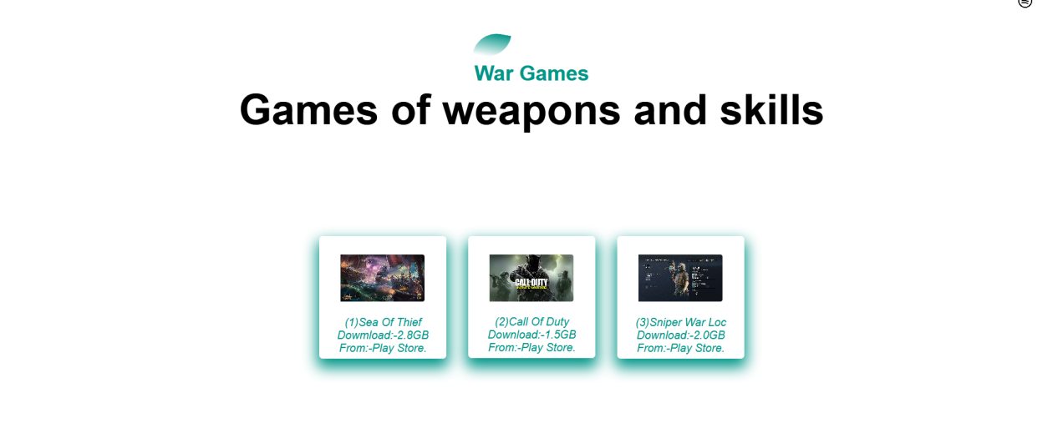

**Html code for 4 page:-**

<!-- War Game -->

<section id="War">

<div class="title-text">

<p>War Games</p>

<h1>Games of weapons and skills </h1>

</div>

<div class="Testimonial-row">

<div class="Testimonial-col">

<div class="user">

<img src="images/B612_20210206_191713_563.jpg">

<div class="user-info">

</div>

</div>

<p>(1)Sea Of Thief<br>

Dowmload:-2.8GB<br>

From:-Play Store.</p>

</div>

<div class="Testimonial-col">

<div class="user">

<img src="images/B612_20210112_103251_995.jpg">

<div class="user-info">

</div>

</div>

<p>(2)Call Of Duty<br>

Download:-1.5GB<br>

From:-Play Store.</p>

</div>

<div class="Testimonial-col">

<div class="user">

<img src="images/B612_20210206_191824_235.jpg">

<div class="user-info">

</div>

</div>

<P>(3)Sniper War Loc<br>

Download:-2.0GB<br>

From:-Play Store.</P>

</div>

</div>

</section>

**Style code for 4 page:-**

/*---War---*/

#War{

width: 100%;

padding: 70px 0;

}

.title-text{

text-align: center;

padding-bottom: 70px;

}

.title-text p{

margin: auto;

font-size: 30px;

color: #009688;

font-weight: bold;

padding-top: 20px;

}

.title-text h1{

font-size: 60px;

}

.War-box{

width: 50%;

margin: auto;

display: flex;

flex-wrap: wrap;

align-items: center;

text-align: center;

}

.War-row{

padding-top: 5%;

width: 40%;

margin: auto;

display: flex;

justify-content: space-between;

align-items: flex-start;

flex-wrap: wrap;

}

.War-col{

flex-basis: 28%;

padding: 6px;

margin-bottom: 30px;

border-radius: 5px;

box-shadow: 0 10px 20px 3px #009688;

cursor: pointer;

transition: transform .5s;

}

.user{

padding-left: 5%;

display: flex;

align-items: center;

margin: 20px 0;

}

.user img{

padding-left: 10%;

width: 120px;

margin-right: 20px;

border-radius: 3px;

}

.War-col p{

color: #009688;

font-style: italic;

text-align: center;

}

.War-col:hover{

transform: translateY(-10px);

}

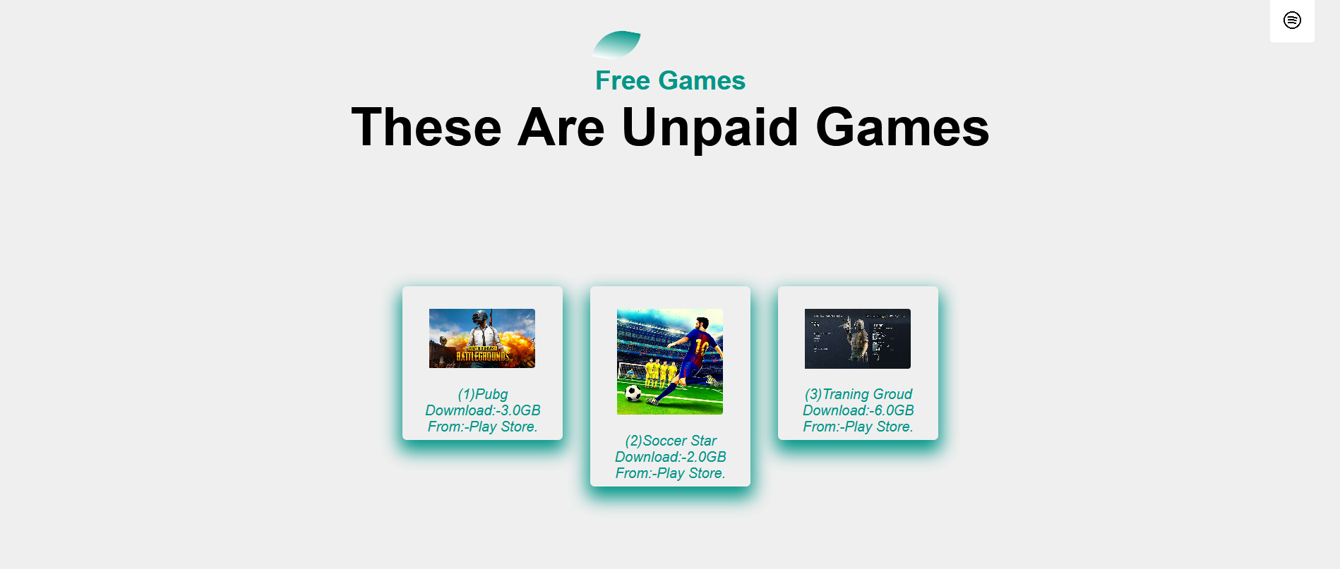

**Html code for 5 page:-**

<!-- Free Games -->

<section id="free">

<div class="title-text">

<p>Free Games</p>

<h1>These Are Unpaid Games</h1>

</div>

<div class="Testimonial-row">

<div class="Testimonial-col">

<div class="user">

<img src="images/B612_20210112_103151_176.jpg">

<div class="user-info">

</div>

</div>

<p>(1)Pubg<br>

Dowmload:-3.0GB<br>

From:-Play Store.</p>

</div>

<div class="Testimonial-col">

<div class="user">

<img src="images/B612_20210206_221042_521.jpg">

<div class="user-info">

</div>

</div>

<p>(2)Soccer Star<br>

Download:-2.0GB<br>

From:-Play Store.</p>

</div>

<div class="Testimonial-col">

<div class="user">

<img src="images/B612_20210206_191824_235.jpg">

<div class="user-info">

</div>

</div>

<P>(3)Traning Groud<br>

Download:-6.0GB<br>

From:-Play Store.</P>

</div>

</div>

</section>

**Style code for 5 page :-**

/*---free---*/

#free{

width: 100%;

padding: 70px 0;

background: #efefef;

}

.title-text{

text-align: center;

padding-bottom: 70px;

}

.title-text p{

margin: auto;

font-size: 30px;

color: #009688;

font-weight: bold;

padding-top: 20px;

}

.title-text h1{

font-size: 60px;

}

.free-box{

width: 50%;

margin: auto;

display: flex;

flex-wrap: wrap;

align-items: center;

text-align: center;

}

.free-row{

padding-top: 5%;

width: 40%;

margin: auto;

display: flex;

justify-content: space-between;

align-items: flex-start;

flex-wrap: wrap;

}

.free-col{

flex-basis: 28%;

padding: 6px;

margin-bottom: 30px;

border-radius: 5px;

box-shadow: 0 10px 20px 3px #009688;

cursor: pointer;

transition: transform .5s;

}

.user{

padding-left: 5%;

display: flex;

align-items: center;

margin: 20px 0;

}

.user img{

padding-left: 10%;

width: 120px;

margin-right: 20px;

border-radius: 3px;

}

.free-col p{

color: #009688;

font-style: italic;

text-align: center;

}

.free-col:hover{

transform: translateY(-10px);

}

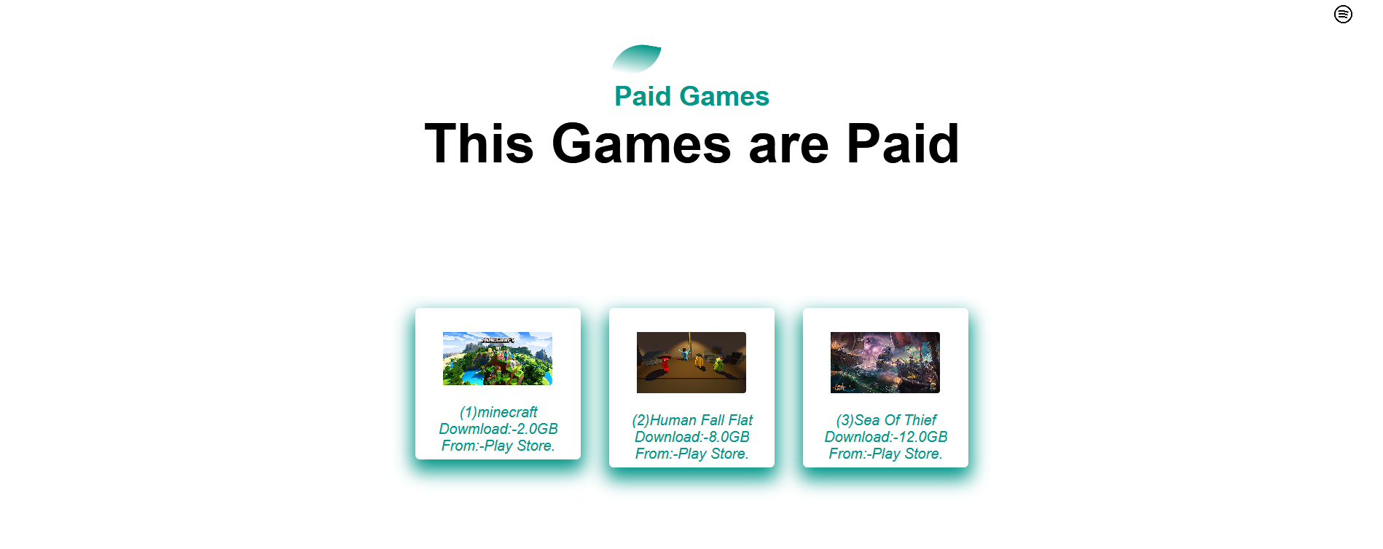

**Html code for 6 page :-**

<!-- Paid Games -->

<section id="Paid">

<div class="title-text">

<p>Paid Games</p>

<h1>This Games are Paid </h1>

</div>

<div class="Testimonial-row">

<div class="Testimonial-col">

<div class="user">

<img src="images/B612_20210206_191807_411.jpg">

<div class="user-info">

</div>

</div>

<p>(1)minecraft<br>

Dowmload:-2.0GB<br>

From:-Play Store.</p>

</div>

<div class="Testimonial-col">

<div class="user">

<img src="images/B612_20210112_103334_164.jpg">

<div class="user-info">

</div>

</div>

**<p>(2)Human Fall Flat<br>**

Download:-8.0GB<br>

From:-Play Store.</p>

</div>

<div class="Testimonial-col">

<div class="user">

<img src="images/B612_20210206_191713_563.jpg">

<div class="user-info">

</div>

</div>

<P>(3)Sea Of Thief<br>

Download:-12.0GB<br>

From:-Play Store.</P>

</div>

</div>

</section>

**Style code for 6 page :-**

/*---paid---*/

#paid{

width: 100%;

padding: 70px 0;

}

.title-text{

text-align: center;

padding-bottom: 70px;

}

.title-text p{

margin: auto;

font-size: 30px;

color: #009688;

font-weight: bold;

padding-top: 20px;

}

.title-text h1{

font-size: 60px;

}

.paid-box{

width: 50%;

margin: auto;

display: flex;

flex-wrap: wrap;

align-items: center;

text-align: center;

}

.paid-row{

padding-top: 5%;

width: 40%;

margin: auto;

display: flex;

justify-content: space-between;

align-items: flex-start;

flex-wrap: wrap;

}

.paid-col{

flex-basis: 28%;

padding: 6px;

margin-bottom: 30px;

border-radius: 5px;

box-shadow: 0 10px 20px 3px #009688;

cursor: pointer;

transition: transform .5s;

}

.user{

padding-left: 5%;

display: flex;

align-items: center;

margin: 20px 0;

}

.user img{

padding-left: 10%;

width: 120px;

margin-right: 20px;

border-radius: 3px;

}

.paid-col p{

color: #009688;

font-style: italic;

text-align: center;

}

.paid-col:hover{

transform: translateY(-10px);

}

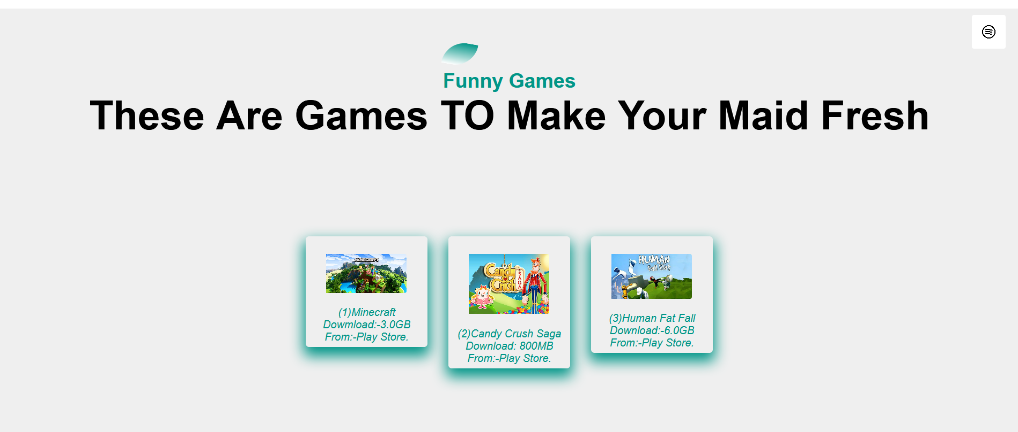

**Hml code for 7 page:-**

<!-- Funny Games -->

<section id="Funny">

<div class="title-text">

<p>Funny Games</p>

<h1>These Are Games TO Make Your Maid Fresh </h1>

</div>

<div class="Testimonial-row">

<div class="Testimonial-col">

<div class="user">

<img src="images/B612_20210206_191807_411.jpg">

<div class="user-info">

</div>

</div>

<p>(1)Minecraft<br>

Dowmload:-3.0GB<br>

From:-Play Store.</p>

</div>

<div class="Testimonial-col">

<div class="user">

<img src="images/B612_20210206_191653_853.jpg">

<div class="user-info">

</div>

</div>

<p>(2)Candy Crush Saga<br>

Download: 800MB<br>

From:-Play Store.</p>

</div>

<div class="Testimonial-col">

<div class="user">

<img src="images/B612_20210206_191643_631.jpg">

<div class="user-info">

</div>

</div>

<P>(3)Human Fat Fall<br>

Download:-6.0GB<br>

From:-Play Store.</P>

</div>

</div>

</section>

**Style code for 7 page :-**

/*---funny---*/

#funny{

width: 100%;

padding: 70px 0;

background: #efefef;

}

.title-text{

text-align: center;

padding-bottom: 70px;

}

.title-text p{

margin: auto;

font-size: 30px;

color: #009688;

font-weight: bold;

padding-top: 20px;

}

.title-text h1{

font-size: 60px;

}

.funny-box{

width: 50%;

margin: auto;

display: flex;

flex-wrap: wrap;

align-items: center;

text-align: center;

}

.funny-row{

padding-top: 5%;

width: 40%;

margin: auto;

display: flex;

justify-content: space-between;

align-items: flex-start;

flex-wrap: wrap;

}

.funny-col{

flex-basis: 28%;

padding: 6px;

margin-bottom: 30px;

border-radius: 5px;

box-shadow: 0 10px 20px 3px #009688;

cursor: pointer;

transition: transform .5s;

}

.user{

padding-left: 5%;

display: flex;

align-items: center;

margin: 20px 0;

}

.user img{

padding-left: 10%;

width: 120px;

margin-right: 20px;

border-radius: 3px;

}

.funny-col p{

color: #009688;

font-style: italic;

text-align: center;

}

.funny-col:hover{

transform: translateY(-10px);

}

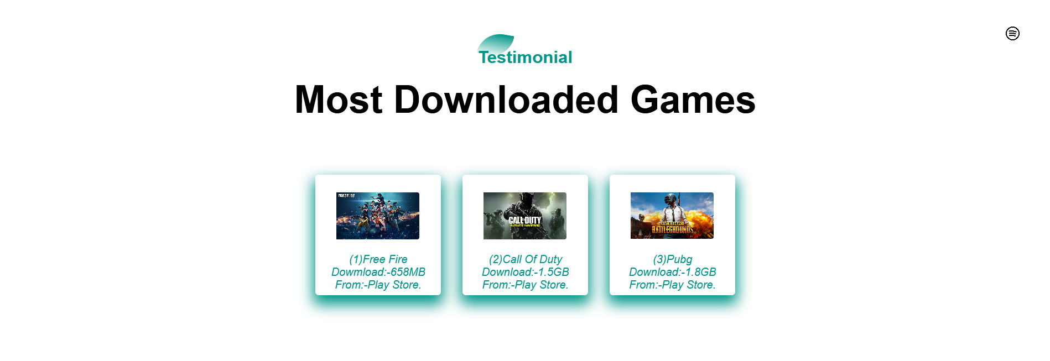

**Html codes for 8 page:-**

<!-- Testimonial -->

<section id="Testimonial">

<div class="title-text">

<p>Testimonial</p>

<h1>Most Downloaded Games</h1>

</div>

<div class="Testimonial-row">

<div class="Testimonial-col">

<div class="user">

<img src="images/B612_20210112_103219_569.jpg">

<div class="user-info">

</div>

</div>

<p>(1)Free Fire<br>

Dowmload:-658MB<br>

From:-Play Store.</p>

</div>

<div class="Testimonial-col">

<div class="user">

<img src="images/B612_20210112_103251_995.jpg">

<div class="user-info">

</div>

</div>

<p>(2)Call Of Duty<br>

Download:-1.5GB<br>

From:-Play Store.

</p>

</div>

<div class="Testimonial-col">

<div class="user">

<img src="images/B612_20210112_103151_176.jpg">

<div class="user-info">

</div>

</div>

<P>(3)Pubg<br>

Download:-1.8GB<br>

From:-Play Store.</P>

</div>

</div>

</section>

**Style codes for 8 page:-**

/*---Testimonial----*/

#Testimonial{

width: 100%;

padding: 70px 0;

}

#Testimonial h1{

padding-top: 1%;

font-size: 55px;

}

.Testimonial-row{

padding-top: 5%;

width: 40%;

margin: auto;

display: flex;

justify-content: space-between;

align-items: flex-start;

flex-wrap: wrap;

}

.Testimonial-col{

flex-basis: 28%;

padding: 6px;

margin-bottom: 30px;

border-radius: 5px;

box-shadow: 0 10px 20px 3px #009688;

cursor: pointer;

transition: transform .5s;

}

.user{

padding-left: 5%;

display: flex;

align-items: center;

margin: 20px 0;

}

.user img{

padding-left: 10%;

width: 120px;

margin-right: 20px;

border-radius: 3px;

}

.Testimonial-col p{

color: #009688;

font-style: italic;

text-align: center;

}

.Testimonial-col:hover{

transform: translateY(-10px);

}

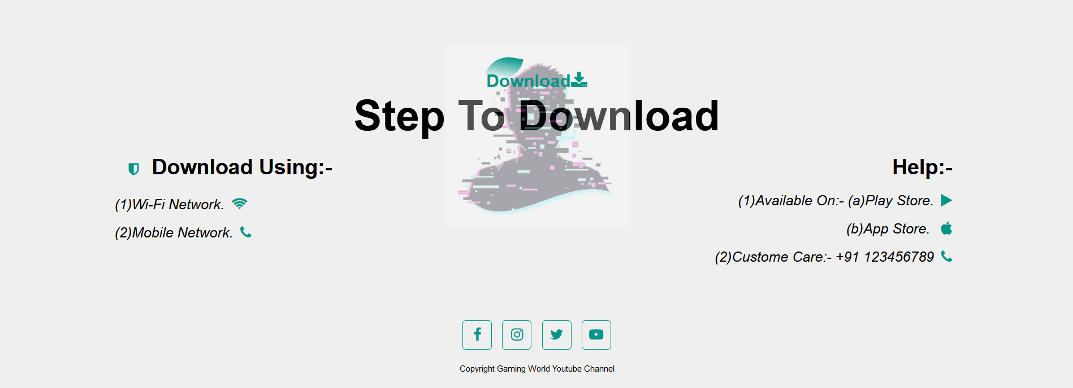

**Html codes of 9 page:-**

<!--Download-->

<section id="Download">

<img src="images/B612_20210112_143900_389.jpg" class="Download-img">

<div class="title-text">

<p>Download<i class="fa fa-download"></i></p>

<h1>Step To Download</h1>

</div>

<div class="Download-row">

<div class="Download-left">

<h1><i class="fa fa-shield"></i> Download Using:-</h1>

<p> (1)Wi-Fi Network.<i class="fa fa-wifi"></i><br>

(2)Mobile Network.<i class="fa fa-phone"></i></p>

</div>

<div class="Download-right">

<h1>Help:-</h1>

<p> (1)Available On:- (a)Play Store.<i class="fa fa-play"></i><br>

(b)App Store. <i class="fa fa-apple"></i><br>

(2)Custome Care:- +91 123456789<i class="fa fa-phone"></i></p>

</div>

</div>

<div class="social-links">

<i class="fa fa-facebook"></i>

<i class="fa fa-instagram"></i>

<i class="fa fa-twitter"></i>

<i class="fa fa-youtube-play"></i>

<p>Copyright Gaming World Youtube Channel</p>

</div>

</section>

**Style codes for 9 page:-**

/*--Download--*/

#Download{

padding: 100px 0 20px;

background: #efefef;

position: relative;

}

.Download h1{

font-size: 55px;

}

.Download-row{

font-size: 20px;

width: 80%;

margin: 0 auto;

display: flex;

justify-content: space-between;

flex-wrap: wrap;

}

.Download-left,.Download-right{

flex-basis: 45%;

padding: 10px;

margin-bottom: 20px;

}

.Download-right{

text-align: right;

}

.Download-row h1{

margin: 10px;

}

.Download-row p{

line-height: 35px;

}

.Download-left .fa,.Download-right .fa{

font-size: 20px;

color: #009688;

margin: 10px;

}

.Download-img{

max-width: 370px;

opacity: 0.30;

position: absolute;

left: 50%;

top: 35%;

transform: translate(-50%,-50%);

}

.Download-right p{

font-style: italic;

}

.Download-left p{

font-style: italic;

}

.social-links{

text-align: center;

}

.social-links .fa{

height: 40px;

width: 40px;

font-size: 20px;

line-height: 40px;

border: 1px solid #009688;

border-radius: 5px;

margin: 40px 5px 0;

color: #009688;

cursor: pointer;

transition: .5s;

}

.social-links .fa:hover{

background: #009688;

color: #fff;

transform: translateY(-7px);

}

.social-links p{

font-size: 12px;

margin-top: 20px;

}

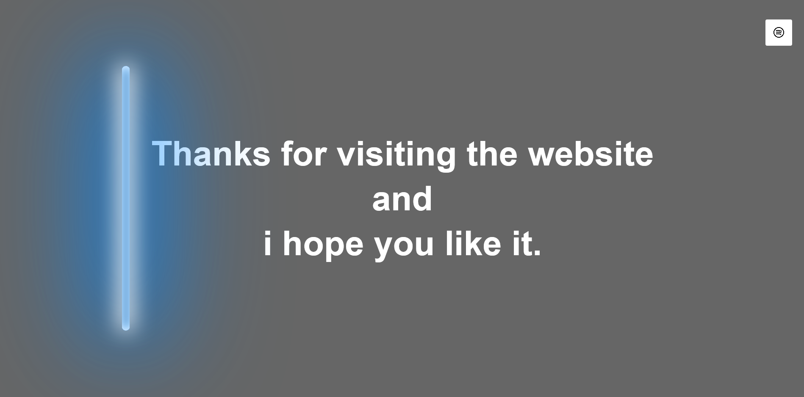

**Html code for 10 page :-**

<!--Thanks Page-->

<section id="Thanks Page">

<div class="hero">

<h1> Thanks for visiting the website <br>

and<br>

i hope you like it.</h1>

<div class="neon-light">

</div>

</div>

</section>

**Style code for 10 page:-**

/*--Thanks Page --*/

.hero{

height: 100vh;

width: 100%;

background-image: linear-gradient(rgba(0,0,0,0.6),rgba(0,0,0,0.6)),url(B612_20210206_191746_173.jpg);

background-size: cover;

background-position: center;

position: relative;

}

.hero h1{

width: 100%;

color: #fff;

text-align: center;

font-family: sans-serif;

font-size: 65px;

line-height: 85px;

position: absolute;

left: 50%;

top: 50%;

transform: translate(-50%,-50%);

}

.neon-light{

width: 15px;

height: 500px;

background: transparent;

border-radius: 15px;

position: absolute;

left: 50%;

top: 50%;

transform: translate(-50%,-50%);

box-shadow: 0 0 40px 5px #fff,

inset 0 0 20px #fff,

0 0 160px 20px #08f,

inset 0 0 20px #08f,

0 0 320px 30px #08f,

inset 0 0 20px #08f;

animation: run 5s linear infinite;

}

@keyframes run{

0%{

left: 10%;

opacity: 0;

}

2%{

left: 10%;

opacity: 1;

}

4%{

left: 10%;

opacity: 0;

}

6%{

left: 10%;

opacity: 1;

}

8%{

left: 10%;

opacity: 0;

}

10%{

left: 10%;

opacity: 1;

}

100%{

left: 90%;

opacity: 1;

}

**Codeing use for closing website:-**

<script>

var menuBtn = document.getElementById('menuBtn')

var sideNav = document.getElementById('sideNav')

var menu = document.getElementById('menu')

sideNav.style.right = "-250px";

menuBtn.onclick = function(){

if(sideNav.style.right == "-250px"){

sideNav.style.right ="0";

menu.src ="images/B612_20210111_133525_401.jpg"

}

else{

sideNav.style.right = "-250px";

menu.src ="images/87409.png"

}

}

var scroll = new SmoothScroll('a[href*="#"]', {

speed: 1000,

speedAsDuration: true

});

</script> </body> </html>

**Thanks for reading the codings.**

**&**

**Please visit the website to see the**

**Effects of the website**